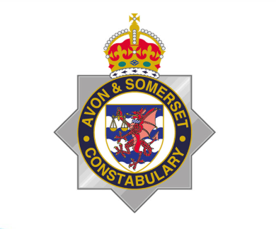
SEVERN VALE NEIGHBOURHOOD POLICING UPDATE
August 2026

On Saturday 22nd August 2026 PC Matthew Blades and PC Tom Clough of Cleveland Police were involved in a head-on collision with a Volkswagen Passat that was travelling the wrong way on the carriageway.
Chief Constable Sarah Crew
The tragic events have been felt deeply across the policing family. I have written to Chief Constable Victoria Fuller to express my condolences following the loss of Cleveland Police (UK) officers, PC Matthew Blades and PC Tom Clough, who died in the line of duty. Our thoughts are with their families, friends and colleagues at this incredibly difficult time. Their loss is felt not only within Cleveland Police, but across policing as a whole. As a mark of respect and solidarity, the flag at Avon and Somerset Police Headquarters is flying at half-mast in honour of their service. I am sharing my letter below on behalf of everyone at Avon and Somerset Police.

Newsletter
Police and Community Safety Update
Police continue to receive reports of males riding e-bikes and Sur-Ron motorcycles in the area, often wearing balaclavas. Residents are asked to report all sightings to the police to help identify those involved.
- If riders are causing an immediate danger or riding dangerously, call 999.
- For sightings or non-emergency information, call 101.
There has also been a report of individuals riding e-bikes stealing a Ring doorbell camera from a property. Police are keen to identify those responsible and are asking anyone with information, CCTV footage, dashcam footage, or witness accounts to come forward. Police have viewed the ring doorbell footage.
Reports have also been received of wing mirrors being damaged by riders on e-bikes while wearing balaclavas. Any information that could assist police investigations should be reported.

Fly-tipping continues to be an issue across the area. Residents are encouraged to remain vigilant and report incidents to South Gloucestershire Council. Where possible, please make a note of:
- Dates and times
- Vehicle registration numbers
- Descriptions of people or vehicles involved
Car Meets
Illegal car meets in Severn Beach remain a concern. Following the serious injuries reported at an event last month, police are continuing to take robust enforcement action against those involved.
Any information or intelligence regarding planned future car meets should be reported to the police. Early information can help prevent disorder and keep the community safe.
Unauthorised Gathering at Marshalls Lane
Police recently responded to an unauthorised Rave at Marshalls Lane, attended by approximately 100 people. The event was shut down quickly, with officers deploying significant resources, including the police drone unit, which proved invaluable in monitoring the situation and helping bring the event to a swift conclusion.
As part of the police response, a van and a sound system were seized, and enquiries remain ongoing.
Thank you for your continued support. Information from the community remains vital in helping police tackle anti-social behaviour, prevent crime, and keep our neighbourhoods safe.

Severn Vale(CN212) Crime Comparison: July vs August 2026
Overall recorded crime fell from 69 offences in July to 47 offences in August, a reduction of 22 offences (-31.9%).
Crime Type | Jul 2026 | Aug 2026
Violence Against the Person | 28 | 20
Arson & Criminal Damage | 10 | 5
Theft | 10 | 7
Burglary | 5 | 2
Vehicle Offences | 5 | 6
Public Order Offences | 1 | 3
Drug Offences | 1 | 1
Miscellaneous Crimes Against Society | 3 | 2
Possession of Weapons | 1 | 0
Sexual Offences | 5 | 0
Robbery | 0 | 1

Key Findings
- Total recorded crime decreased by 32%, from 69 offences in July to 47 in August.
- Violence Against the Person remained the highest-volume offence category but reduced significantly by 8 offences (29%).
- Arson and Criminal Damage halved from 10 to 5 offences.
- Sexual Offences reduced from 5 offences in July to none recorded in August.
- Theft fell by 3 offences (30%).
- Burglary fell from 5 to 2 offences (60% reduction).
- Vehicle Offences showed a slight increase from 5 to 6 offences.
- Public Order Offences increased from 1 to 3 offences.
- Robbery was recorded in August (1 offence) whereas none were recorded in July.
- Drug Offences remained stable at 1 offence.
ASB Comparison: July vs August 2026
CN212 - Severn Vale
Overall ASB incidents decreased from 5 occurrences in July to 4 occurrences in August, representing a 20% reduction.
ASB Type | Jul 2026 | Aug 2026
ASB Personal (APE) | 3 | 2
ASB Nuisance (ANU) | 1 | 2
ASB Environmental (AEN) | 1 | 0
Total ASB | 5 | 4
Key Findings
- Total recorded ASB reduced slightly from 5 incidents in July to 4 incidents in August.
- ASB Personal remained the most common ASB category, although incidents fell from 3 to 2.
- ASB Nuisance increased from 1 to 2 incidents, accounting for 50% of all ASB reports in August.
- ASB Environmental reduced from 1 incident in July to none recorded in August.
ASB Calls (STORM) Comparison: July vs August 2026
CN212 - Severn Vale & Pilning
Overall ASB-related calls to police reduced significantly from 14 calls in July to 4 calls in August, a decrease of 10 calls (-71%).
ASB Type | Jul 2026 | Aug 2026
ASB - Nuisance | 8 | 0
ASB - Personal | 2 | 0
ASB - Environmental | 2 | 1
Anti-Social Behaviour (General) | 2 | 3
Total Calls | 14 | 4
Key Findings
- ASB-related calls fell substantially by 71%, from 14 calls in July to 4 calls in August.
- ASB Nuisance saw the largest reduction, falling from 8 calls to none recorded in August.
- ASB Personal reduced from 2 calls to zero.
- ASB Environmental reduced slightly from 2 calls to 1 call.
- The only increase was in general Anti-Social Behaviour calls, which rose from 2 to 3 calls.
- Despite the slight increase in general ASB reports, the overall trend shows a marked reduction in demand linked to anti-social behaviour.

Rogue Trader Awareness Talks
We are looking to deliver more community talks on the dangers of rogue traders and doorstep crime and are seeking local groups that may be interested in hosting a short presentation.
These talks help residents understand how rogue traders operate, how to spot the warning signs, and the financial and emotional impact these offences can have on victims. They also provide practical advice on how to stay safe and where to seek help.
We would particularly like to hear from:
- Lunch clubs
- Coffee mornings
- Community groups
- Social clubs
- Retirement groups
- Faith groups
- Any small groups of residents who would benefit from the information
If your group would be interested in hosting a talk, please get in touch. We are happy to visit small groups and tailor the session to the audience. By raising awareness together, we can help protect vulnerable members of our community from becoming victims of these crimes.

Rogue Trader Warning
Police are reminding residents to be vigilant of rogue traders operating in the area. These individuals often go door-to-door offering services such as pressure washing driveways, patios, or roofs, cleaning gutters, or carrying out urgent roof repairs.
A common tactic is to claim they have spotted a serious problem with your roof or property that requires immediate attention. They may offer a seemingly reasonable quote at first, but once work has started, the price can increase dramatically, leaving homeowners under pressure to pay large sums of money for unnecessary or poor-quality work.
Rogue traders often target elderly and vulnerable residents, believing they may be more likely to trust doorstep callers or feel pressured into agreeing to work. We encourage residents to keep an eye out for elderly or vulnerable neighbours and check in with them if they appear to be having unexpected work carried out following a doorstep visit.
Residents should be particularly cautious of anyone who:
- Turns up uninvited and offers property maintenance services.
- Claims urgent repairs are needed without providing evidence.
- Pressures you into making an immediate decision.
- Requests cash payments.
- Is unwilling to provide written quotations, receipts, or proof of insurance.
- Fails to explain your cancellation rights.
For contracts agreed in your home, consumers are generally entitled to a 14-day cooling-off period, allowing them time to reconsider. Rogue traders often fail to provide this information and may seek to pressure residents into making immediate decisions.
To protect yourself:
- Never agree to work on the spot.
- Obtain at least three written quotes from reputable companies.
- Ask for references and check online reviews.
- Use traders recommended by trusted friends, family, or recognised trade schemes.
- Seek a second opinion before agreeing to any work.
If you believe you have been targeted by a rogue trader, report the matter to Trading Standards. If you feel threatened or intimidated, call 999 immediately.
Remember: Genuine traders will not pressure you into making a quick decision. If something doesn't feel right, take time to stop, think and check before agreeing to any work.
Beat Surgeries – Come and Talk to Your Local Neighbourhood Team
Your local Neighbourhood Policing Team regularly holds Beat Surgeries and Talk to Us events across the Severn Vale and Pilning area, giving residents the opportunity to raise concerns, discuss local issues, seek crime prevention advice, and meet their local officers.
Whether you want to discuss anti-social behaviour, road safety concerns, rural crime, or simply find out more about what your local team is doing in the community, we encourage you to come along and speak with us. No appointment is necessary.
Upcoming events can be found on the Avon and Somerset Police website, including sessions held in locations across the neighbourhood area.
To view future Beat Surgeries, local policing priorities, and details of your Neighbourhood Policing Team, visit:
https://www.avonandsomerset.police.uk/your-area/severn-vale-and-pilning/
We look forward to meeting residents and hearing about the issues that matter most to you.

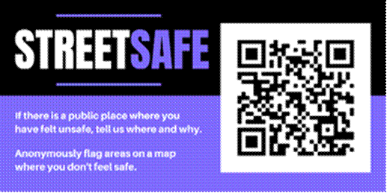
Crime Stoppers
If you need to report a crime but are worried about sharing your personal information, use the following number for Crime stoppers.
0800555111
100% anonymous.
Community SpeedWatch
Community SpeedWatch gives local people the ability to actively get involved in road safety. The scheme also educates motorists who speed on the impact their actions have and the danger they pose to other road users and pedestrians.

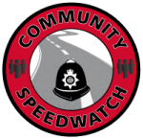
What does Community SpeedWatch do?
Community SpeedWatch is made up of a network of community volunteers who monitor traffic speeds through scheduled high-visibility roadside sessions. These sessions are part of our evidence-based approach to addressing speeding and road safety concerns.
Our objectives are to:
- reduce average speeds on Avon and Somerset’s roads
- lower the number and severity of road casualties
- enhance road safety to improve the quality of life in our communities
These objectives form part of a wider aim to prioritise the reduction of fatal and serious injury collisions. They also align with the Avon and Somerset Police Road Safety Strategy and the .
I want to report a speeding concern
If speeding is an issue in your area, you should complete our

Community Speed Concern form
to let us know.
How Community SpeedWatch works
A Community SpeedWatch can be set up in any area that is governed by either a 20, 30 or 40 miles per hour speed limit. Once a scheme is set up, activities will include:
- trained volunteers monitoring set areas, with access to support and resources
- warning letters sent to owners of vehicles observed speeding, along with advice to help change their driving behaviour
- police taking further action against persistent and high-end speeding offenders
Joining Community SpeedWatch
There are two routes to becoming a Community SpeedWatch volunteer. You can either join an existing scheme or set up your own if there isn’t one covering the area you would like to monitor.
For more information, please follow the below link to access the necessary form.
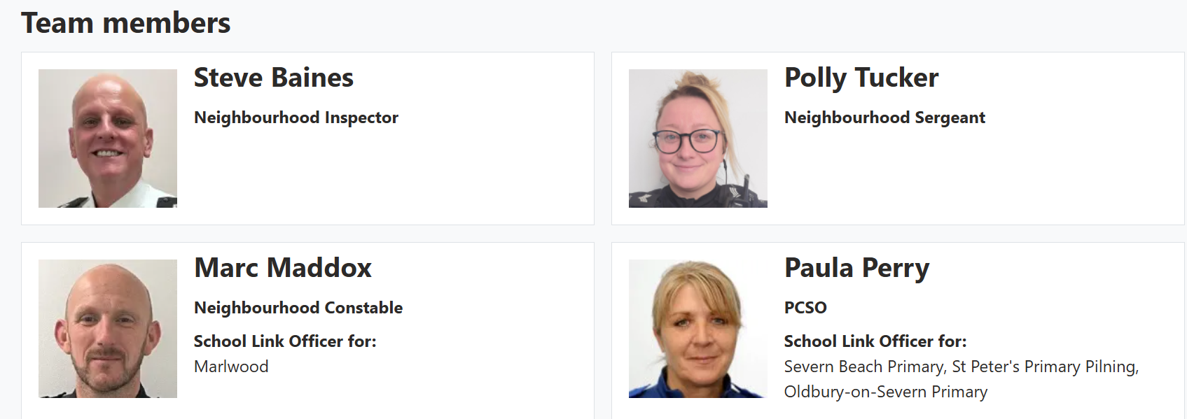

Following the flash flood in the Rasuwa district and the Nepal-China border area on 26 August, the Nepalese government has established a toll-free emergency Nepalese language number (1234), and a dedicated hotline (1144) accessible in Nepal. If you’re affected and need assistance from the UK government, call:
- from Nepal +977 (0)14237100
- from the UK +44 (0) 207 008 5000

